port GmbH / Regensburger Straße 7b / 06132 Halle / Saale
Tel: +49 345-77755-0
Press contact: Dietmar R. Franke (CEO)
eMail: drf@port.de
www.port.de / www.port-automation.de

PRESS RELEASE

SoM IoT / Industry 4.0 modules for integration into LINUX environments.
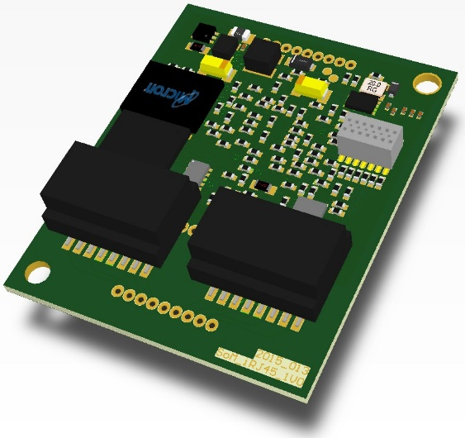

PORT is expanding its SoM (System on Module) offering for real-time communication applications for use on Linux. The SoM IoT / Industry 4.0 modules offer PROFINET CCB and EtherNetIP on board and can now be easily integrated into LINUX environments.

The SoM-IoT Real Time Communication Module provides a cost effective and easy to integrate communication solution. The market-leading real-time communication systems such as PROFINET CCB, EtherNetIP (EtherCAT and CANopen on request) are made available in just one module.
An extensive range of tools for management, integration and design drastically reduce development and integration times. With an integrated update service you always stay up to date.
The SoM-IoT Real Time communication module is prepared for use with various Ethernet ports such as RJ45, Mini RJ45 (IP20 applications) as well as M12 or M8 (IP54 applications). So the PHYs and the transformers are already available on board on the SoM. So only the SoM module and the corresponding Ethernet connectors have to be integrated on the host module.
The SPI of the SoM-RIN32M3 module is supposed to connect the module to the external application processor. Due to the independence between the Module Clock and the clock of the external application processor, the serial transmission with the SPI interface in asynchronous mode is performed by 3 module pins.
The application controller as SPI master determines the SPI communication mode. The SPI data format can first be switched between MSB and LSB. The number of bits in each transmission can be changed to any number from 8 to 16 or to 20, 24 or 32 bits. The communication is based on a 128-byte transfer buffer that can transport multiple requests.
The communication is based on a cyclic scheme in which process data can be transmitted cyclically with each request of the application control. Non-real-time communication (RPC) uses the same transport, but processing is decoupled from real-time communication. Thus real-time data can be exchanged independently of function calls of the API.
System requirements
The SoM works with any Linux system that provides an SPI interface as well as an I²C interface via the kernel. Furthermore, high precision timers are needed.
evaluation
PORT offers a SoM EVAL platform which can be tested together with a Raspberry PI under LINUX. The SoM Module EVAL board has a PMOD / ARDUINO interface and can thus be combined with other EVAL boards.
https://www.port-automation.com/en/products/som-module-embedded/som-iot-based-on-renesas-rin32m3.html
https://www.port-automation.com/fileadmin/user_upload/port-automation/SOM_Module/SoM_RIN32M3/SoM_-_Datenblatt_RIN32M3EC_preliminary.pdf
https://www.port-automation.com/en/products/arduino-pmod-boards/arduinopmod-iot-module.html

about port GmbH
port is a leading supplier of industrial communication technologies such as CAN/CANopen and Industrial Ethernet including the PROFINET, EtherNet/IP, EtherCAT and POWERLINK protocols. port GmbH has been located in Halle/Saale since 1990. For more than five years port has successfully provided Industrial Ethernet Technology such as PROFINET, EtherCAT, POWERLINK and EtherNet/IP. port offers stacks, tools, workshops and integration support as well as custom hardware and software development, including manufacturing of electronic devices and systems.

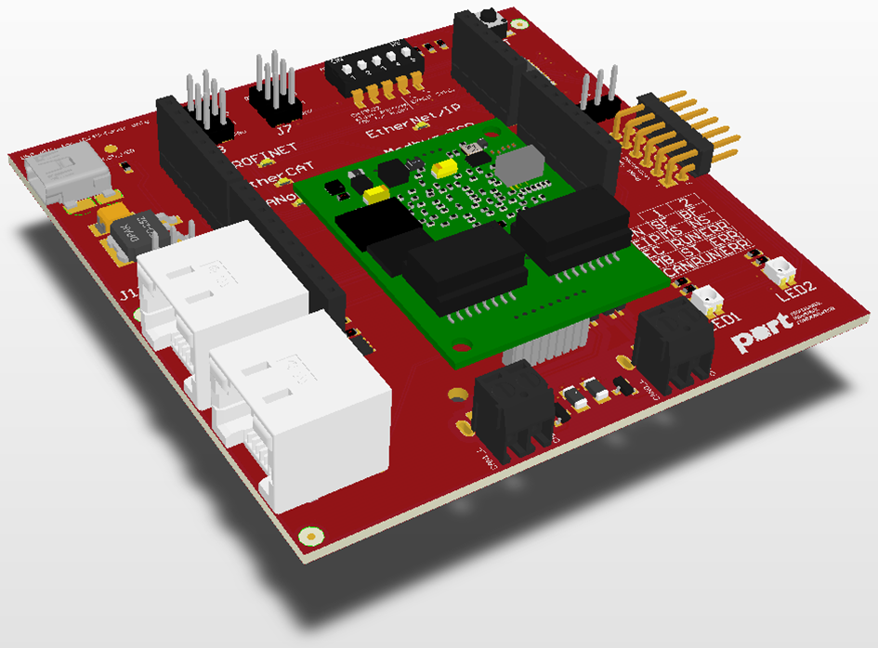
Figure 1-ARDUINO_PMOD Board

Figure 2 - LINUX Logo

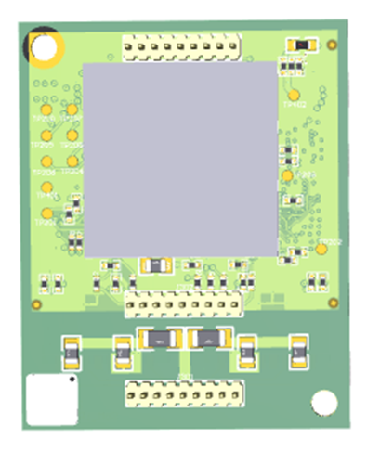
Figure 3 - SoM IOT PCB Bottom

